H.T No
Regulations:
A15

Sreenidhi Institute of Science and Technology
(An Autonomous Institution)
Code No: 5B515 Date: 28-Jan-2025 (AN)
B.Tech III Year I- Semester External Examination, January- 2025 (Supplementary)
Kinematics of Machinery (ME)

Time: 3 Hours Max.Marks:75 Note: a) No additional answer sheets will be provided.
b) All sub-parts of a question must be answered at one place only, otherwise it will not be valued.
c) Missing data can be assumed suitably.

Bloom's Cognitive Levels of Learning (BCLL)
Remember | L1 | Apply | L3 | Evaluate | L5
Understand | L2 | Analyze | L4 | Create | L6

Part - A Max.Marks:25

Answer all QUESTIONS.
 |  | BCLL | CO(s) | Marks
1 | Classify the kinematic pairs. Draw any two pairs. | L2 | CO1 | [2M]
2 | State and prove Kennedy theorem. | L2 | CO2 | [2M]
3 | Distinguish between Davi’s and Ackermann’s steering mechanism. | L2 | CO3 | [2M]
4 | What are the different motions of the follower? | L2 | CO4 | [2M]
5 | Compare length of path of contact and length of arc of contact. | L3 | CO5 | [2M]
6 | Classify chains | L2 | CO6 | [3M]
7 | Define the inversion of a mechanism. | L2 | CO2 | [3M]
8 | What are the difference between the Ackerman and Davis steering gear mechanism | L2 | CO3 | [3M]
9 | State the law of gearing. | L2 | CO5 | [3M]
10 | What is Dimensional synthesis? | L2 | CO1 | [3M]

Part – B Max.Marks:50
ANSWER ANY FIVE QUESTIONS. EACH QUESTION CARRIES 10 MARKS.

 |  |  | BCLL | CO(s) | Marks
11. | a) | Explain the Kutzbach’s criterion for degrees of freedom of plane mechanism. | L2 | CO1 | [5M]
 | b) | Find the degrees of freedom for following two mechanisms.  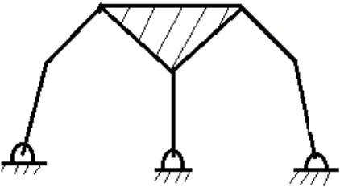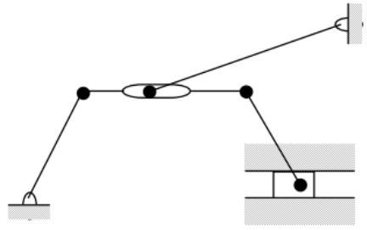 | L5 | CO1 | [5M]
12. |  | ABCD is a four bar chain with fixed link AD. The length of the links are: AB = 40 mm, BC = 150 mm, CD = 80 mm and AD = 150 mm. E is a point on BC 60 mm from B. The crank AB rotates at 120 RPM clockwise. Draw the velocity and acceleration diagrams when angle BAD = 600 and find the angular velocity of the links BC and CD. Find the velocity of point E. Also find angular acceleration of link BC. | L3 | CO2 | [10M]
13. |  | A Hooke’s joint connects two shafts which are having 160˚ as the included angle. The driving shaft rotates uniformly at 1500 r.p.m. Find the maximum angular acceleration of the driven shaft and the maximum torque required if the driven shaft carries a flywheel of mass 12 kg and the 100 mm radius of gyration. | L5 | CO3 | [10M]
14. |  | Draw the cam profile for following conditions:  Follower type = knife edge follower, in-line; lift = 40 mm; base circle radius = 50 mm; out stroke with Uniform Velocity, for 120º cam rotation; dwell for 60º cam rotation; return stroke with SHM, for 90º cam rotation; dwell for the remaining period. Evaluate max. velocity and acceleration during out stroke and return stroke if the cam rotates at 1200 rpm in clockwise direction. | L5 | CO4 | [10M]
15. |  | Two mating involute spur gears with module pitch of 8 mm have 23 and 57 teeth of 20˚ pressure angle. The addenda on pinion and gear wheels are equal to one module. i). Number of pairs of teeth in contact,  ii). Angle turned through by pinion and gear wheels, and  iii). Ratio of sliding velocity to rolling velocity at the beginning of the contact, at the pitch point and at the end of contact. | L4 | CO5 | [10M]
16. | a) | What are different types of chains? Explain, with neat sketches, the power transmission in chains. | L2 | CO6 | [5M]
 | b) | Derive an expression for the length of the belt in open belt drive | L3 | CO6 | [5M]
17. | a) | Explain about the Number Synthesis. | L2 | CO1 | [4M]
 | b) | Discuss the rubbing velocity at a Pin-Joint for velocity analysis in any mechanism | L2 | CO2 | [3M]
 | c) | Explain with a neat sketch the working of Peaucellier Mechanism. | L2 | CO3 | [3M]
18. | a) | What are the different types of cams? | L2 | CO4 | [4M]
 | b) | What are the different forms of gear teeth? | L2 | CO5 | [3M]
 | c) | Explain slip, creep of belts. | L2 | CO6 | [3M]

-- 00 -- 00 –

